1. Objective
The objective of this project is to design and develop an AI-powered agent using
LangChain and a local Large Language Model (LLM) to price financial instruments
such as:
✅Bonds
✅ Index Options
✅ Equity Linked Notes (ELNs)

2. System Overview
This project integrates Artificial Intelligence with Financial Engineering by combining:
✅ A local LLM (Mistral via Ollama)
✅ A tool-based agent framework (LangChain)
✅ A custom financial pricing engine

3. Core Components
3.1 Pricing Engine (pricer.py)
A custom-built module that performs financial calculations.
Key Functions:
✅price_bond() → Calculates bond price
✅price_option() → Prices index options
✅price_eln() → Prices equity linked notes

3.2 Tool Wrapper (agent_tools.py)
A function that connects user input with the pricing engine.
Functionality:
✅Parses input text
✅Identifies instrument type
✅Calls appropriate pricing function
✅Returns formatted output

Example Input: price bond 1000 0.05 5
👉 This acts as the bridge between LLM and backend logic.

  - Local LLM Setup (Ollama + Mistral)
✅Runs the Mistral model locally
✅Eliminates dependency on external APIs
✅Provides cost efficiency and data privacy
👉 This is the intelligence and reasoning engine.

3.4 Tool Definition
The pricing function is converted into a LangChain tool:
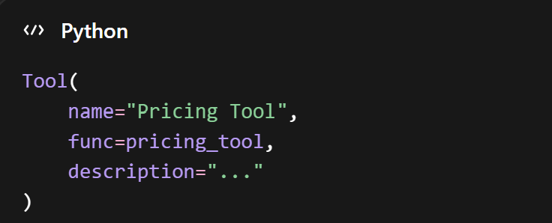
👉 Enables the LLM to decide when to call the pricing logic.

3.5 Agent Creation
The agent is created using LangChain:
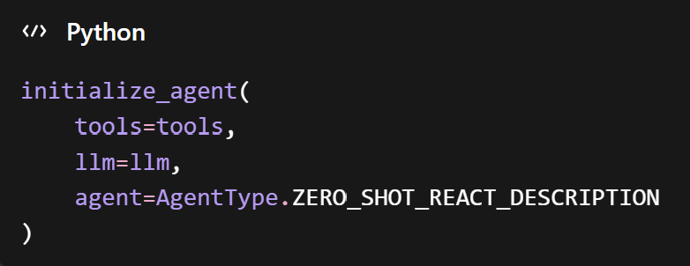

Agent Capabilities:
✅Interprets user queries
✅Performs step-by-step reasoning
✅Selects appropriate tools
✅Executes computations

👉 This is the decision-making component.

4. Execution Flow
Example Input: price bond 1000 0.05 5
Step-by-Step Process:
✅User enters query
✅LLM interprets the request
✅Agent selects the "Pricing Tool"
✅Tool parses the input
✅Pricing engine computes result
✅Output is returned to user

5. System Architecture
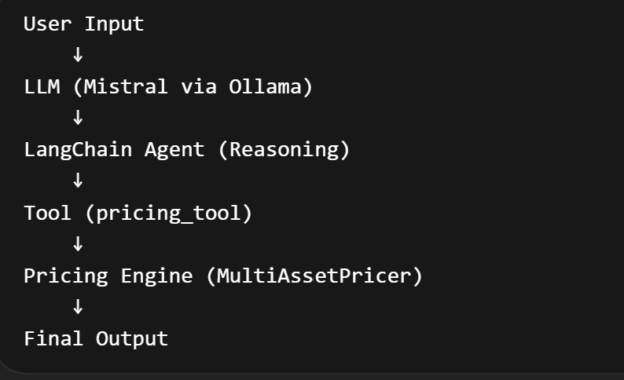

Learning
✅ Development of a local LLM-powered agent
✅ A multi-asset pricing system
✅ Implementation of tool-based reasoning systems
✅ Creation of a modular and scalable architecture

